LIVE UNREAL RUN SHEET 1 OF 4 SETUP
Prepare the live Material and VFX demo
Teach the current Material & VFX Tools in Unreal 5.7.4. The native Slate tab and PySide window share the same Python planner and live backend. Use the isolated classroom fixture and preserve the saved baseline.
Before class | Launch Scripts/launch_live_demo.ps1 from Week07UnrealPython. It opens W07_MaterialVFXLab and runs the non-destructive preflight. If this project is already open, use its existing editor and Tools > Material & VFX Tools.
Check the fixture | Two plain cubes, three empty pedestals, no placed effects. The near cube is W07_Crate_Target; the far cube is W07_Crate_Protected. Both use the same shared mesh. Open the map from Content/Week07/Maps if needed.
Prepare inputs | Select W07_Crate_Target in the Outliner. In Content/Week07/LiveDemo/Textures select all three T_Crate textures: BaseColor, Normal and ORM. Content Browser selection and level selection are separate. Wait for browser selection to update before Preview.
Panel and naming | Tools > Material & VFX Tools. Material Setup, slot 0, fresh MI_ name such as MI_Crate_Live_01. Do not overwrite an existing instance. For PySide: Python console: import week07_tools as w7; w7.show_assistants().
Fallback readiness | Open live-demo.html in a browser before teaching. It contains actual baseline, material, VFX and native-panel captures, plus read-aloud prompts. It works offline without Unreal or Qt. If a failure persists beyond 30 seconds, use it within the same demo slot.

Optional selection helpers in the Unreal Python console
from week07_tooling.editor import live_demo
print(live_demo.preflight())
live_demo.select_material()
live_demo.select_vfx()
Run one helper at a time; Preview only after the browser updates. Helpers select inputs and frame the camera. They do not apply changes, reset the map, delete assets or save.
Go/no-go: baseline visible, both workflow previews available, fallback already open. Native plugin binaries match UE 5.7.4 on this Windows machine; another engine build requires rebuilding the plugin. Use the offline fallback if that prerequisite fails.

LIVE UNREAL RUN SHEET 2 OF 4 MATERIAL 3:49–3:56
Demonstrate material setup
Ask students to predict scope before Apply. The goal is one new material instance and one component override, while the second cube and shared mesh stay unchanged.
Elapsed | Do and say
0:00–1:00 | Show both cubes. “They share a mesh. Which one should change, and what must remain untouched?” Point to the selected target and three textures.
1:00–2:30 | Choose Material Setup, slot 0 and a fresh MI_ name. Preview. Read the destination, parent, three texture mappings and one target. “Preview has not changed the scene.”
2:30–4:00 | Apply once. Show the near blue cube and far plain cube. Check the instance parent and texture parameters if time permits. “A success message needs a visible scope check.”
4:00–5:00 | Try Preview again with the same output name. It must block overwrite. “What should happen on a repeat?”
5:00–6:00 | Use Edit > Undo only when its label identifies the material assignment. Target returns to plain. The new instance remains. Explain that assignment Undo and asset cleanup are separate.
6:00–7:00 | Leave the unsaved draft for later inspection; use a fresh name next time. Ask one student to state input, action, expected result and protected scope.

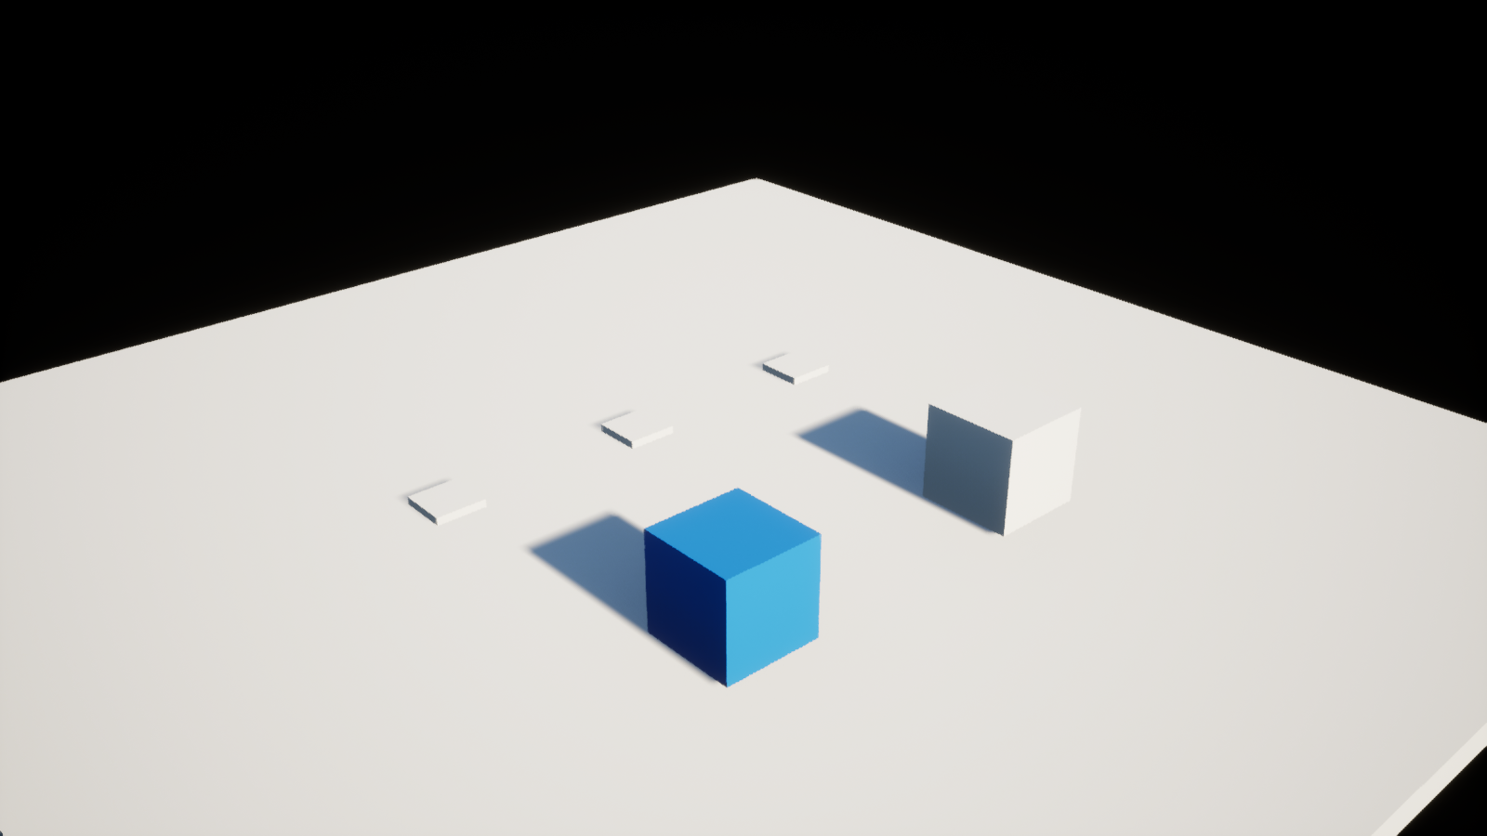
Actual Unreal capture: target becomes blue; protected cube remains plain. The scene was inspected in the running editor, not simulated for this image.
3:56–3:58 UI comparison: native Slate belongs to the editor tab system; PySide offers the current staged interface. Both call the same workflow. Use existing Stage 1/2/3 practice captures for the brief visual comparison; do not repeat the whole operation.

LIVE UNREAL RUN SHEET 3 OF 4 VFX 3:58–4:02
Demonstrate bounded VFX placement
Place the prepared classroom fountain at three tagged anchors. Separate predictable placement from runtime performance: a bounded batch does not establish a frame-time budget.
Elapsed | Do and say
0:00–0:45 | Select W07_VFXAnchor_1, _2 and _3. Choose VFX Placement, classroom fountain, scale 1.0. “How many effects should this create, and where?”
0:45–1:30 | Preview: three anchors, three effects, their positions and rotations. Apply once. Show three visible fountains.
1:30–2:15 | Reselect the same anchors if necessary. Preview again: occupied anchors must block repeated placement. “The tool checks duplication before mutation.”
2:15–3:00 | Edit > Undo the known VFX placement. Verify all three effects disappear; pedestals remain. If Undo label is unfamiliar, stop and use recovery instructions.
3:00–4:00 | Ask: “What have we verified? What remains unmeasured?” Answer: placement and recovery checked; runtime performance on target hardware remains unmeasured. Hand off at 4:02.

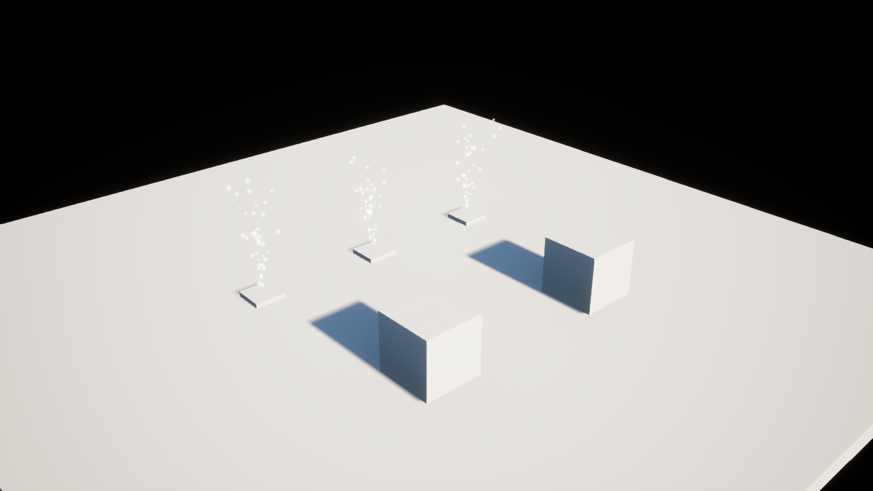
Actual Unreal capture: three fountains at the three markers, after material Undo. Discrete captured state; not a live recording.
Preset review: one lightweight GPU sprite emitter, 90 particles/second, lifetime 1.4–1.75 seconds, sprite size 6–12 cm, default Niagara sprite material. Three new effects maximum; scale 0.25–1; anchors at least 100 cm apart. Effect Type: 5000 cm distance, maximum 4 instances per system and 8 overall. This classroom review does not certify packaged-game performance.

LIVE UNREAL RUN SHEET 4 OF 4 RECOVERY
Recover and keep teaching
Use one short recovery attempt, then switch to the prepared browser walkthrough. State what is observed and what is still unverified. Do not spend the peer-review time debugging the editor.
Symptom | Recovery | Teaching fallback
Preview blocked | Read the message. Check target + textures separately, slot 0, valid fresh MI_ name, or three tagged anchors. Preview again. | Show the captured preview and ask students to identify scope.
Selection changed after Preview | Restore intended selection and Preview again. Apply consumes the old plan even when blocked. | Discuss why the old plan should expire.
Duplicate instance or occupied anchor | Use a new MI_ name; for effects, Undo the known previous batch. Do not overwrite assets or pile on effects. | Show the repeat-placement block capture.
Session expired or panel failed | Native: Reconnect, then Preview. PySide: close and reopen using w7.show_assistants(). | Use the other UI only if already prepared; otherwise browser.
Unexpected partial result | Stop. Inspect target and protected cube, output asset and placed Actors. Failed material setup restores assignments but may retain a draft. Do not Save All. | Describe the uncertainty; use verified captured states.
Undo state is unclear | Do not issue repeated Undo blindly. Reopen the saved W07_MaterialVFXLab and decline saving only the rehearsal map edits. Inspect any new instance separately. | Continue from baseline capture.
Editor or dependency unavailable | Switch to live-demo.html. No engine, Qt, network or installation is needed. | Use prediction, observed result, repeat block and recovery prompts.

Reset after class | Do not save the changed demo map. Reopen its saved baseline and verify two plain cubes and zero effects. New instance cleanup is separate: inspect references before deleting only your rehearsal asset. Never delete the Generated folder as a reset.
Verified in this rehearsal | UE 5.7.4 material creation/readback, protected cube/shared mesh unchanged, material Undo with asset retained, three exact VFX placements, duplicate block, VFX Undo, invalid/missing/stale selections, live PySide workflows and reopening. Native UI Preview/Apply is checked separately in the evidence report.
Scope of evidence | Actual editor results and discrete screenshots establish this fixture workflow. They do not establish every possible asset, target-machine performance, or a packaged-game result. See the rehearsal report beside the fallback captures for the recorded checks.

